Step-by-Step Project Creation
1. Go to Spring Initializer
Open: Spring Initializr
Fill in:
- Group: com.cognizant
- Artifact: spring-learn
- Dependencies:
  - Spring Web
  - Spring Boot DevTools
Click Generate → Download ZIP
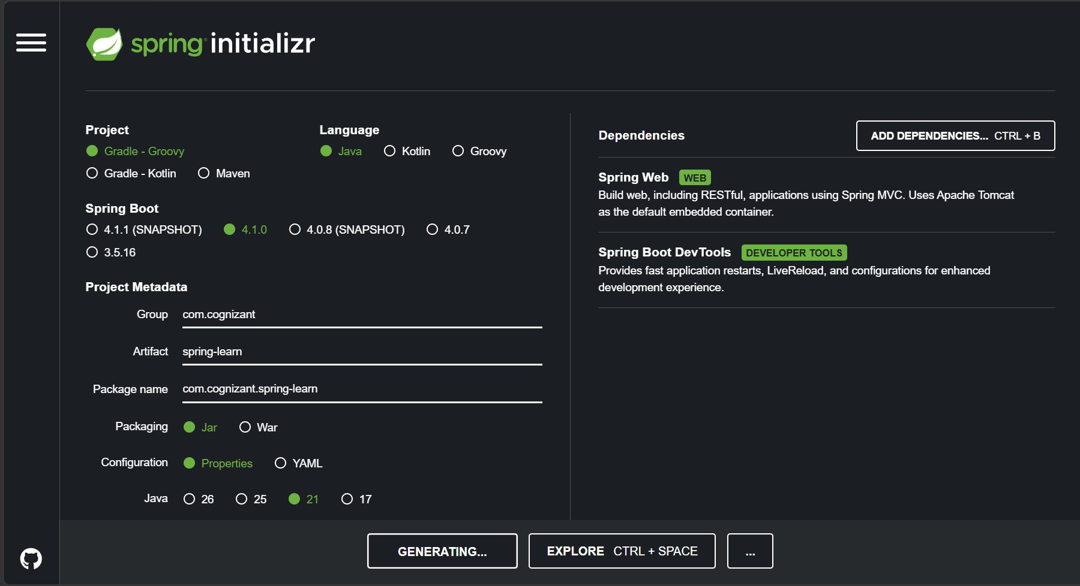
2. Extract & Setup
- Extract ZIP into your Eclipse workspace root folder
3. Build Using Maven
Run in terminal (inside project folder):
mvn clean package -Dhttp.proxyHost=proxy.cognizant.com -Dhttp.proxyPort=6050 -Dhttps.proxyHost=proxy.cognizant.com -Dhttps.proxyPort=6050 -Dhttp.proxyUser=12345

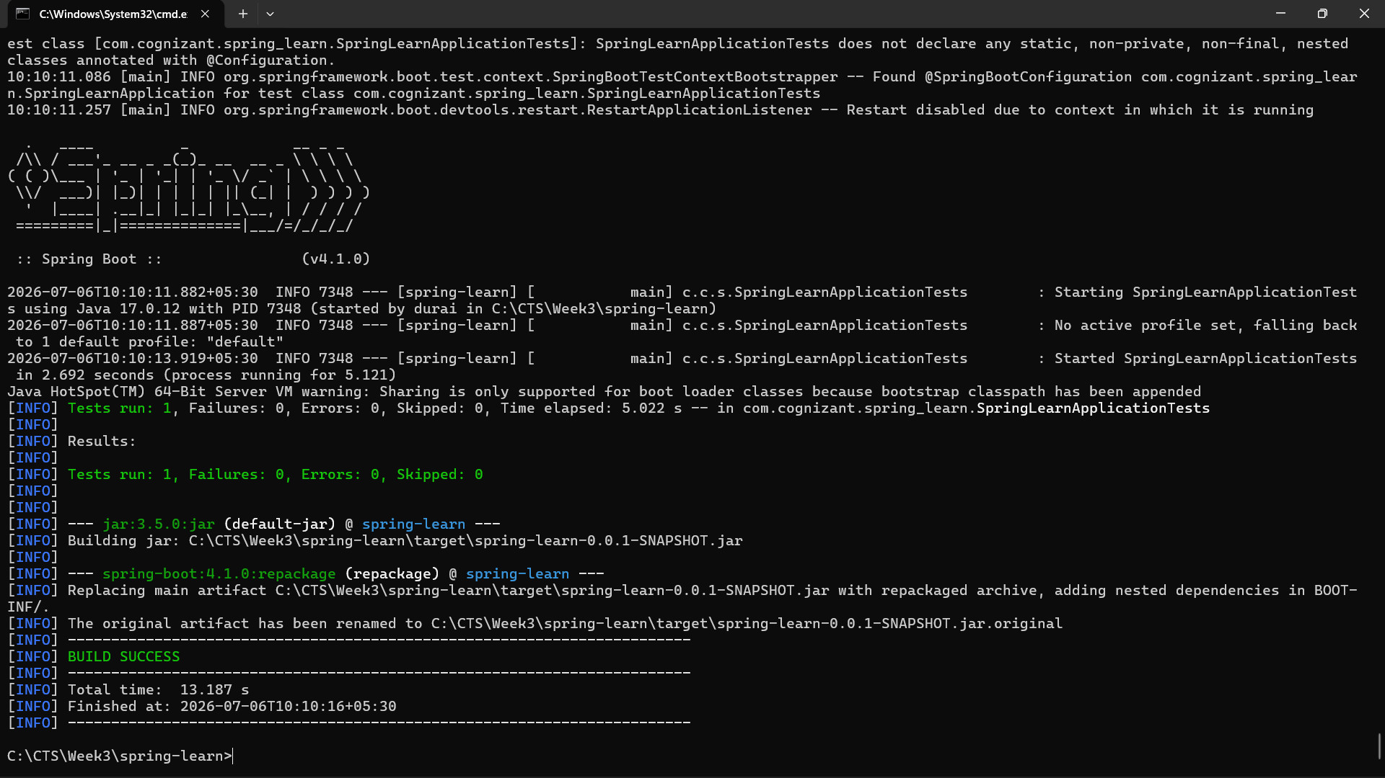
4. Import into Eclipse
- Go to:
File → Import → Maven → Existing Maven Projects
- Select extracted folder → Finish

5. Add Logs in Main Class
Open:
SpringLearnApplication.java - Modify: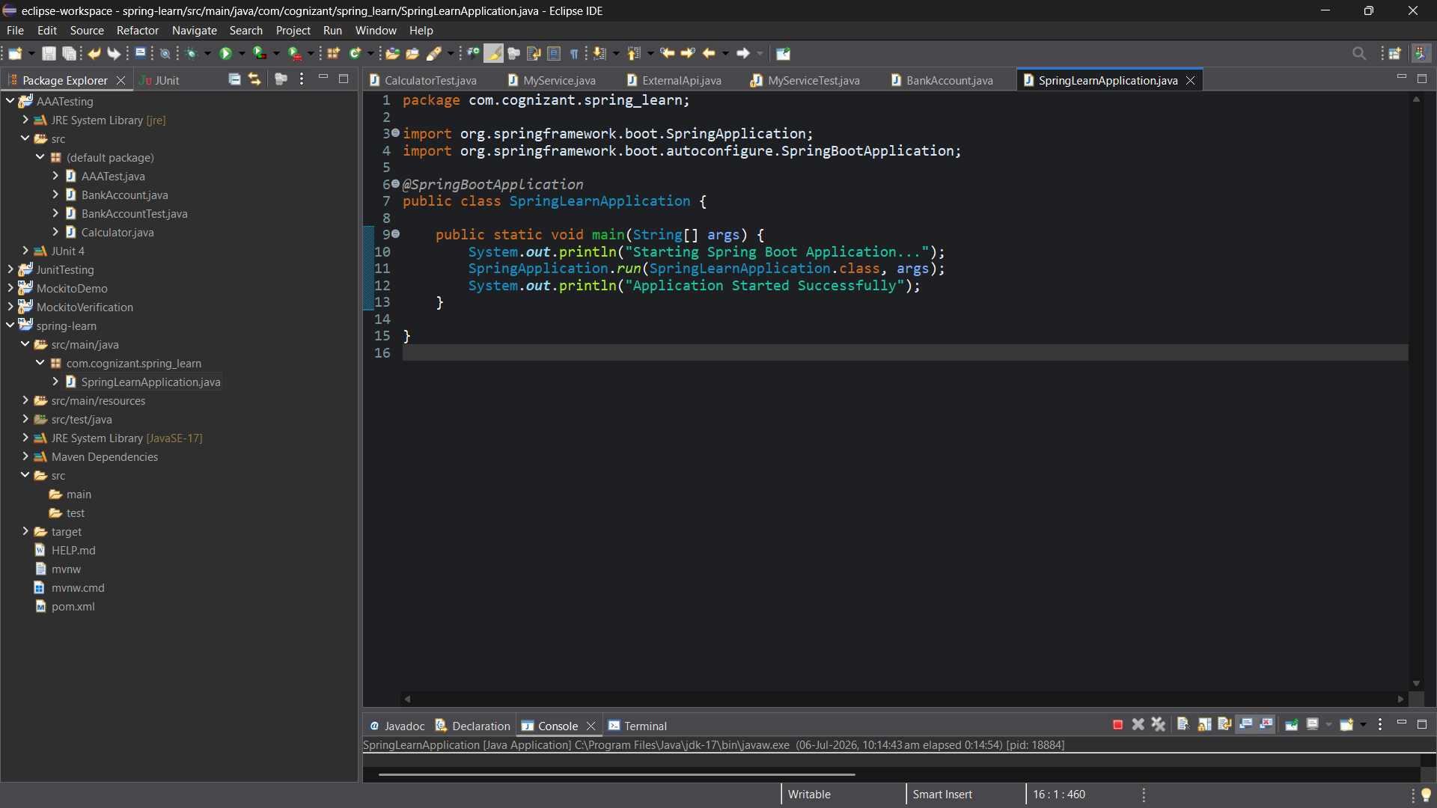
6. Run the Application
- Right-click class → Run As → Java Application
